**Arduino UNO**

The UNO is the best board to get started with electronics and coding. It is the most robust board you can start playing with.

The Arduino Uno has a resettable polyfuse that protects your computer's USB ports from shorts and overcurrent. Although most computers provide their own internal protection, the fuse provides an extra layer of protection. If more than 500 mA is applied to the USB port, the fuse will automatically break the connection until the short or overload is removed.

The board can operate on an external supply from 6 to 20 volts. If supplied with less than 7V, however, the 5V pin may supply less than five volts and the board may become unstable. If using more than 12V, the voltage regulator may overheat and damage the board. The recommended range is 7 to 12 volts.

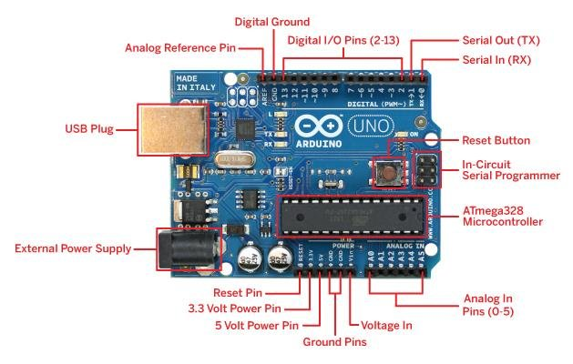

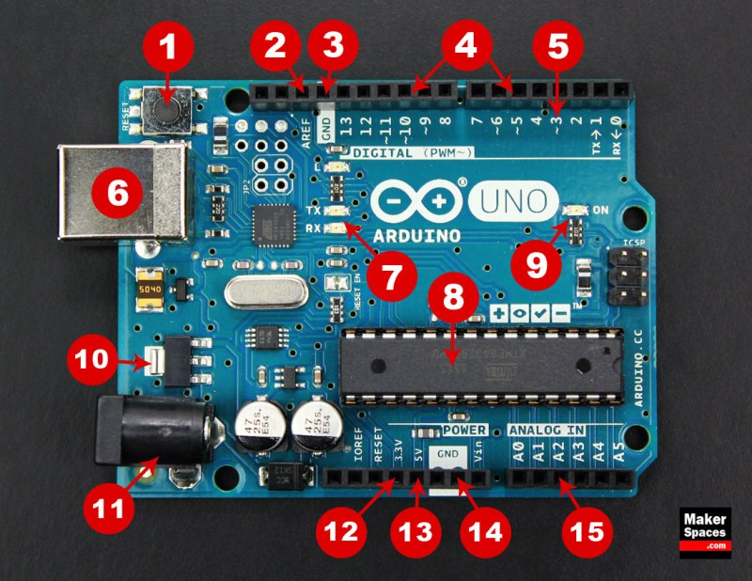

**Board Breakdown**

Here are the components that make up an Arduino board and what each of their functions are.

1. **Reset Button** – This will restart any code that is loaded to the Arduino board
2. **AREF** – Stands for “Analog Reference” and is used to set an external reference voltage
3. **Ground Pin** – There are a few ground pins on the Arduino and they all work the same
4. **Digital Input/Output** –  Pins 0-13 can be used for digital input or output
5. **PWM** – The pins marked with the (~) symbol can simulate analog output
6. **USB Connection** – Used for powering up your Arduino and uploading sketches
7. **TX/RX** – Transmit and receive data indication LEDs
8. **ATmega Microcontroller** –  This is the brains and is where the programs are stored
9. **Power LED Indicator** – This LED lights up anytime the board is plugged in a power source
10. **Voltage Regulator** – This controls the amount of voltage going into the Arduino board
11. **DC Power Barrel Jack**– This is used for powering your Arduino with a power supply
12. **3.3V Pin** – This pin supplies 3.3 volts of power to your projects
13. **5V Pin** – This pin supplies 5 volts of power to your projects
14. **Ground Pins** –  There are a few ground pins on the Arduino and they all work the same
15. **Analog Pins** –  These pins can read the signal from an analog sensor and convert it to digital

**Technical Specification**

|  |  |
| --- | --- |
| Microcontroller | [ATmega328P](http://www.atmel.com/Images/Atmel-42735-8-bit-AVR-Microcontroller-ATmega328-328P_Datasheet.pdf) |
| Operating Voltage | 5V |
| Input Voltage (recommended) | 7-12V |
| Input Voltage (limit) | 6-20V |
| Digital I/O Pins | 14 (of which 6 provide PWM output) |
| PWM Digital I/O Pins | 6 |
| Analog Input Pins | 6 |
| DC Current per I/O Pin | 20 mA |
| DC Current for 3.3V Pin | 50 mA |
| Flash Memory | 32 KB of which 0.5 KB used by bootloader |
| SRAM | 2 KB (ATmega328P) |
| EEPROM | 1 KB (ATmega328P) |
| Clock Speed | 16 MHz |
| LED_BUILTIN | 13 |
| Length | 68.6 mm |
| Width | 53.4 mm |
| Weight | 25 g |

**Programming**

The Arduino program contains two main parts: setup () and loop (). The name of the functions implies their purpose and activity: setup () sets up the Arduino hardware, such as specifying which I/O lines is planned to use, and whether they are inputs or outputs.

The loop () function is repeated endlessly when the Arduino runs. Arduino IDE (Integrated development environment) is used to write the program and dump into the Arduino board. The program was written and dumped into the Arduino.

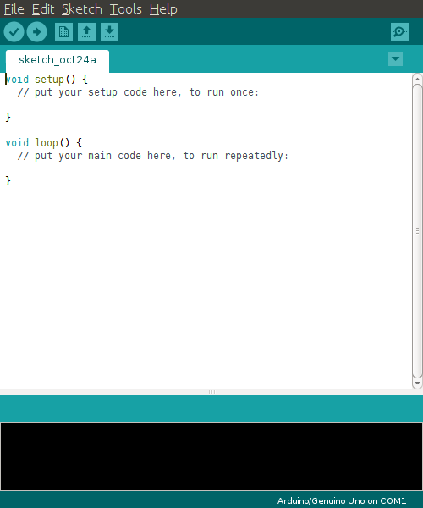

The software used on the host computer is known as an integrated development environment, or IDE The development environment is based on the open source processing platform.

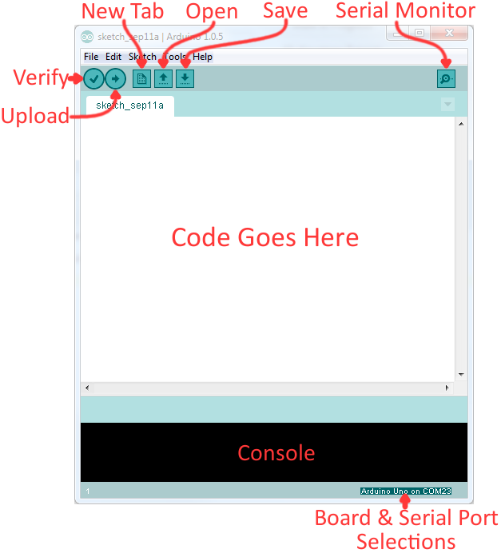

**Download the IDE**

First, you must download the IDE and install it. Start by visiting [Arduino’s software page](https://www.arduino.cc/en/Main/Software). The IDE is available for most common operating systems, including Windows, Mac OS X, and Linux, so be sure to download the correct version for your OS. If you are using Windows 7 or older, do not download the Windows app version, as this requires Windows 8.1 or Windows 10.

**Multimeter**

**Analog Digital**

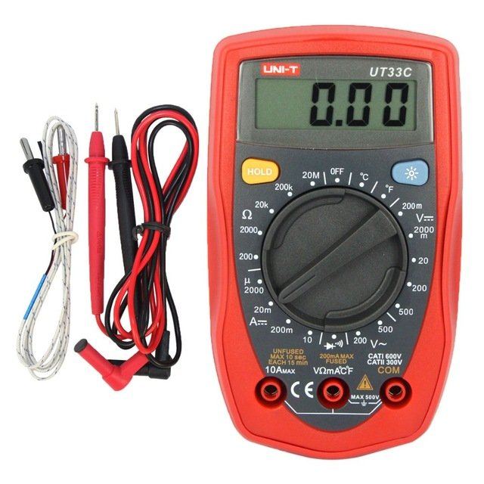

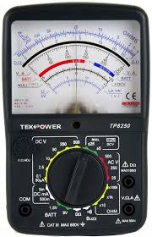

A **multimeter** or a multitester, also known as a VOM (volt-ohm-milliammeter), is an electronic measuring instrument that combines several measurement functions in one unit. Analog **multimeters** use a microammeter with a moving pointer to display readings.

A **digital multimeter** (DMM) is a test tool **used to** measure two or more electrical values—principally voltage (volts), current (amps) and resistance (ohms). It is a standard diagnostic tool for technicians in the electrical/electronic industries.